Format and Guidelines of Abstract for
Font: Times New Roman
Font size: 14
Alignment: Centre
Line spacing: Single

ANQ Congress 2023 Ho Chi Minh city, Vietnam
Font: Times New Roman
Font size: 11
Alignment: Centre
Line spacing: Single

One line spacing

Author A¹, Author B² and Author C^{3,}*
Font: Times New Roman
Font size: 9
Alignment: Centre
Line spacing: Single

¹ Academic or Business Affiliation, Address, City, Province, Zip Code
² Academic or Business Affiliation, Address, City, Province, Zip Code
*Corresponding Author: E-mail, Telephone Number, Fax. Number

Abstract
The instructions below are described to guide authors who wish to submit an abstract to the ANQ Congress 2023 Ho Chi Minh city, Vietnam. The submitted abstract must be clear, concise, and well agree with the conference template to obtain the consistent form with other papers, therefore it can be collected in the conference CD-ROM proceedings uniformly. Use this document as a template if you are using MS Word. Otherwise, use this document as a guideline to setup your manuscript.
Keywords: 3 – 5 keywords should be provided here to assist with indexing of the article.
Page setup
Paper size: A4
Orientation: Portrait

Font: Times New Roman
Font size: 10
Alignment: Justify
Line spacing: Single

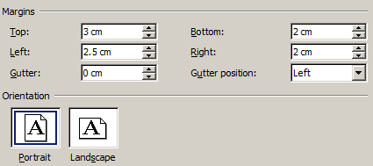

Format and Guidelines of Abstract for
ANQ Congress 2023 Ho Chi Minh city, Vietnam

Author A¹, Author B² and Author C^{1,}*

¹ Academic or Business Affiliation, Address, City, Province, Zip Code
² Academic or Business Affiliation, Address, City, Province, Zip Code
*Corresponding Author: E-mail, Telephone Number, Fax. Number

Abstract
The instructions below are described to guide authors who wish to submit an abstract to the ANQ Congress 2023 Ho Chi Minh city, Vietnam. The submitted abstract must be clear, concise, and well agree with the conference template to obtain the consistent form with other papers, therefore it can be collected in the conference CD-ROM proceedings uniformly. Use this document as a template if you are using MS Word. Otherwise, use this document as a guideline to setup your manuscript.
Keywords: 3 – 5 keywords should be provided here to assist with indexing of the article.

